FAST Payroll Report: User Access Test
- Please log onto FAST: https://fast.uoit.ca/fastportal/desktopdefault.aspx
- Click on the Financial Reporting icon on the left-hand side:
- Click on ‘Operating Statement’ in the grey menu near the top under the DC/OT logos and drag the cursor down to ‘Current Year Actuals by Position’:
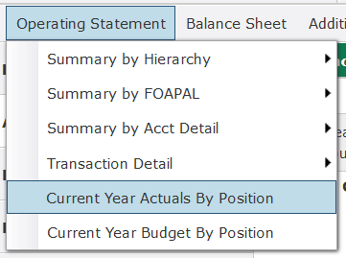

Note: If this report does not appear in the drop-down then the test is over. Please email adam.king@ontariotechu.ca ASAP.
- Click on the report and enter in the Fund & Orgn for which the user has access:
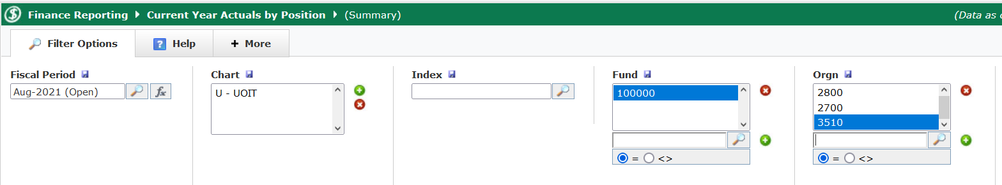

- Then click on the green ‘Execute Report’ button in the bottom –right corner (or hit Ctrl+Enter):
- If you see a list of your unit’s employees with payroll values for each month and the non-zero $ amounts are blue and clickable then Congrats! You have access.
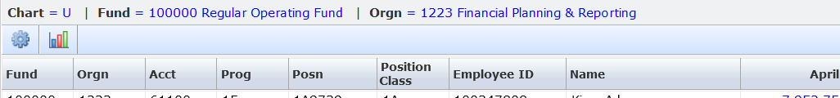

If no report results are generated or the non-zero data values are not hyperlinked, please email adam.king@ontariotechu.ca ASAP.

